Are quasi-stationary waves and planetary waves the same?

A good abstract will begin with a short description of the problem being addressed, briefly describe the new data or analyses, then briefly states the main conclusion(s) and how they are supported and uncertainties.

# Introduction

Atmospheric planetary waves are blabalbaal… In some latitudes and times of the year they exhibit some degree of stationarity

At present, there exists a lack of consistency in the literature when it comes to a

# Story

…

Given a set of atmospheric fields, we define “zonal waves” (ZW; sometimes also called planetary waves) as waves observed in each individual “instantaneous” field and quasi-stationary waves (QS) as the resulting waves in the mean field. While these definitions depend on which are the “instantaneous field” in question and the averaging timescales used, they illustrate that, ZWs are properties of the *elements* of the set, while the QS is a property of the set as a whole. This is an important distinction with theoretical and methodological implications that is not always appreciated in the literature.

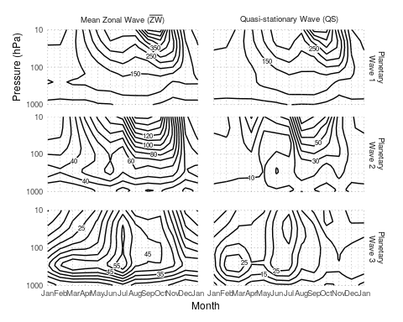

Seasonal cycle of amplitude of the geopotential planetary waves 1 to 3 at 60S computed as the mean amplitude of the monthly waves ($\overline{ZW}$) and as the amplitude of the mean wave (QS). The period of analysis is 1950 to 1998. The left column reproduces Figure 3 from Rao, Fernandez, and Franchito (2004).

As an example, Figure shows the monthly seasonal cycle of amplitude of planetary waves at 60S using monthly fields from the NCEP/NCAR reanalysis (Kalnay et al. (1996)) between 1950 and 1998. The left column ($\overline{ZW}$) reproduces Figure 3 from Rao, Fernandez, and Franchito (2004) and is computed by taking –for each month and level– the average amplitude of the 49 individual amplitudes. The right column (QS), on the other hand, is computed by taking the amplitude of the average geopotential field for each month and level.

The resulting fields convey different information. First, the amplitude of $\overline{ZW}$ fields is always greater than the one for QS fields. This is a that explains Rao, Fernandez, and Franchito (2004)’s observation that their Wave 1 amplitude was greater than that reported by Hurrell, Loon, and Shea (1998). Secondly, they have different annual cycles and vertical structures. QS2, for example, has a strong minimum in the low stratosphere during the austral autumn that is not apparent in $\overline{ZW2}$. Similarly, the austral winter mid-tropospheric maximum is very well defined in $\overline{ZW3}$ but not so in QS3. Thirdly, the relative importance between each wave number vary. $\overline{ZW}$ fields show, for example, a preponderance of wave 2 over 3 in almost every level and month. However, the QS3 has greater amplitude than QS2 in the first half of the year. In contrast with wave-numbers 2 and 3, $\overline{ZW1}$ and QS1 fields are very similar.

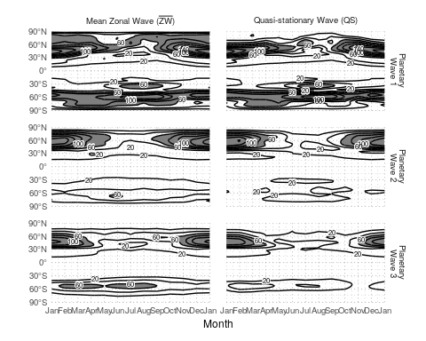

Seasonal cycle of amplitude of the geopotential planetary waves 2 at 300hPa computed as the mean amplitude of the monthly waves ($\overline{ZW}$) and as the amplitude of the mean wave (QS). From monthly NCEP/NCAR Reanalisys, 1979 to 2017.

These differences are related to the degree of stationarity of zonal waves and are location-dependent. Figure show the same variable that Figure but for 300hPa. The contrast between the northern and southern hemisphere is not only evident in the amplitude of the planetary waves, but also in the comparison between $\overline{ZW}$ and QS. Specially for wave-numbers 2 and 3, $\overline{ZW}$ and QS fields are very similar in the north but they have significant differences in the south.

## Stationarity

Another important consequence of the distinction between $\overline{ZW}$ and QS is that the quotient between the two can be used as a measure of stationarity. As an analogy with the constancy of the wind (Singer (1967)), planetary wave stationarity can be estimated as

It can be shown that $\overset{^}{S}=1$ for completely stationary waves and that $E(\overset{^}{S})=n^{−1/2}$ for completely non-stationary waves (where $n$ is the sample size).

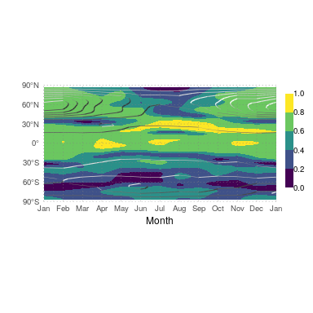

Seasonal cycle of stationarity of the 300hPa geopotential QS2 computed using Equation (shaded) and $\overline{ZW2}$ (contours). From monthly NCEP/NCAR Reanalisys, 1979 to 2017.

As an example, Figure shows $S$ for QS2 computed using Equation . The southern hemisphere clearly shows a lower degree of QS2 stationarity than the northern hemisphere or the tropics. In the northern mid latitudes there is a seasonal cycle of stationarity that follows the seasonal cycle of $\overline{ZW}$ (Figure ). In the southern hemisphere, instead, the June maximum of $\overline{ZW}$ coincides with a minimum of stationarity.

While $\overset{^}{S}$ is used –sometimes with a $arcsin$ transformation (Singer (1967))– in the meteorological literature in the context of wind steadiness (), to our knowledge this is the first time it has been applied to the study of atmospheric waves. Furthermore, its statistical properties are not well studied. For example, it can be seen that the estimation of $\overset{^}{S}$ from a finite sample has a positive bias that is inversely proportional to the population stationarity, but its convergence properties are not explored.

## QS activity

Defining quasi-stationary waves as a climatological property of a set of atmospheric fields, precludes, in principle, the possibility of quantifying a QS metric that applies to instantaneous fields. It would seem impossible to, for example, construct an time series of QS activity that could be use as a basis for correlations with other variables, compositions or for use in other methodologies. But there are ways of solving this issue.

One possibility is recognising that individual fields can be characterised by their degree of similarity with the climatological QS. The index produced by Raphael (2004) for the QS3 is an example. While not expressly a measure of similarity, it is sensitive to wave 3 patterns with phase close to the stationary phase. Yuan and Li (2008) use Principal Component Analysis on the meridional wind field; the spatial pattern of the leading mode is very similar to the QS3 and so a time series can be obtained by projecting each instantaneous field to it.

Another way of constructing a time series is to exploit the fact the timescale dependence of QS. By applying a running mean with a suitable windows before computing wave amplitudes, one obtains the QS wave amplitude of that window.

# Conclusions

The fact that zonal waves (ZW) and quasi-stationary waves (QS) are two distinct but related phenomena has both practical and theoretical implications.

Researchers should be aware of which phenomena they want to study and use the appropriate methods.

Comparison between results should also be made having this issues in mind. For example, Irving and Simmonds (2015) compare their planetary wave activity index with Raphael (2004)’s wave 3 index and conclude that the later cannot account for events with waves far removed from their climatological position. However, if we understand it as an index of QS3 similitude, then that is a feature, not a bug.

Since planetary waves are generally more stationary in the northern hemisphere, these issues are more critical in studies of the southern hemisphere.

For clarity, when reporting results that use mean amplitude of waves, researchers should always describe if they are using the mean amplitude of individual waves or the amplitude of the mean wave.

Besides those direct implications, separating ZW and QS can lead to novel levels of analysis. Here, we showed a simple metric of the stationarity, but others are possible.

Hurrell, James W, Harry van Loon, and Dennis J Shea. 1998. “The Mean State of the Troposphere.” In *Meteorology of the Southern Hemisphere*, edited by David J Karoly and Dayton G Vincent, 1–46. Boston, MA: American Meteorological Society. doi:[10.1007/978-1-935704-10-2_1](https://doi.org/10.1007/978-1-935704-10-2_1).

Irving, Damien, and Ian Simmonds. 2015. “A novel approach to diagnosing Southern Hemisphere planetary wave activity and its influence on regional climate variability.” *Journal of Climate* 28 (23): 9041–57. doi:[10.1175/JCLI-D-15-0287.1](https://doi.org/10.1175/JCLI-D-15-0287.1).

Kalnay, E, M Kanamitsu, R Kistler, W Collins, D Deaven, L Gandin, M Iredell, et al. 1996. “The NCEP/NCAR 40-year reanalysis project.” *Bulletin of the American Meteorological Society* 77 (3): 437–71. doi:[10.1175/1520-0477(1996)077<0437:TNYRP>2.0.CO;2](https://doi.org/10.1175/1520-0477(1996)077<0437:TNYRP>2.0.CO;2).

Rao, V. Brahmananda, J. P. R. Fernandez, and S. H. Franchito. 2004. “Quasi-stationary waves in the southern hemisphere during El Nina and La Nina events.” *Annales Geophysicae* 22 (3): 789–806.

Raphael, Marilyn N. 2004. “A zonal wave 3 index for the Southern Hemisphere.” *Geophysical Research Letters* 31 (23): 1–4. doi:[10.1029/2004GL020365](https://doi.org/10.1029/2004GL020365).

Singer, Irving A. 1967. “Steadiness of the Wind.” *Journal of Applied Meteorology* 6 (6): 1033–8. doi:[10.1175/1520-0450(1967)006<1033:sotw>2.0.co;2](https://doi.org/10.1175/1520-0450(1967)006<1033:sotw>2.0.co;2).

Yuan, Xiaojun, and Cuihua Li. 2008. “Climate modes in southern high latitudes and their impacts on Antarctic sea ice.” *Journal of Geophysical Research: Oceans* 113 (6): 1–13. doi:[10.1029/2006JC004067](https://doi.org/10.1029/2006JC004067).